EARLY BIRDS
CLASS

_________________
BIBLE CHART - LAPBOOK (bible friends who prayed)
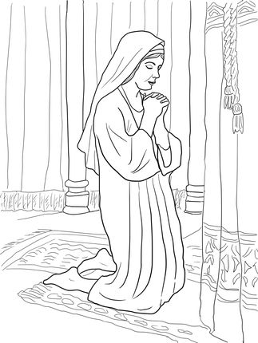

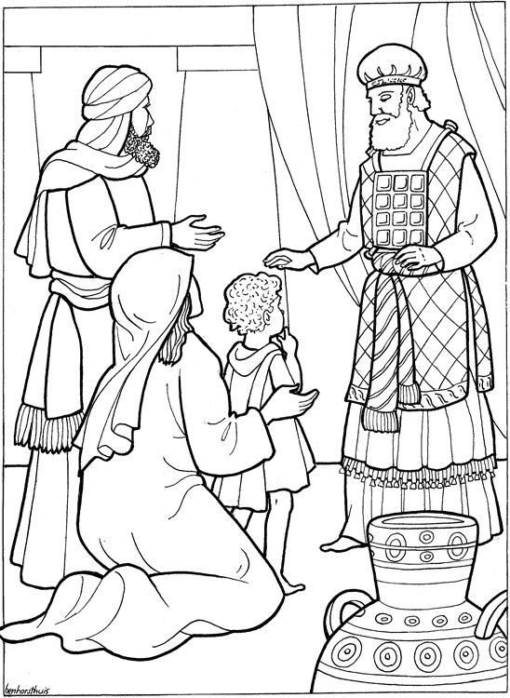
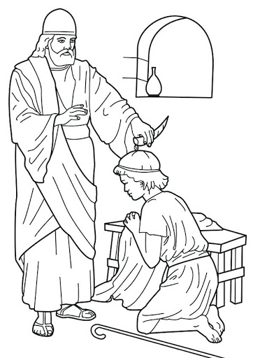

SAMUEL

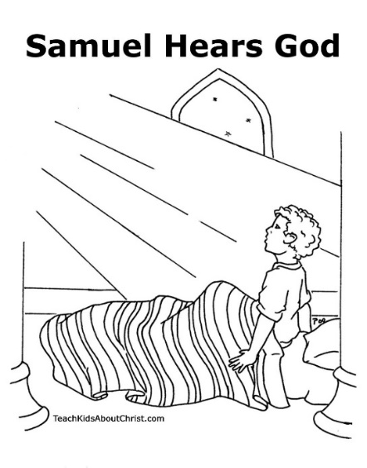

But the Lord said to Samuel,…the Lord does not see as man sees ; for man looks at the outward appearance, but the Lord looks at the heart.” 1 Samuel 16:7

DANIEL

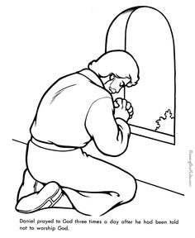

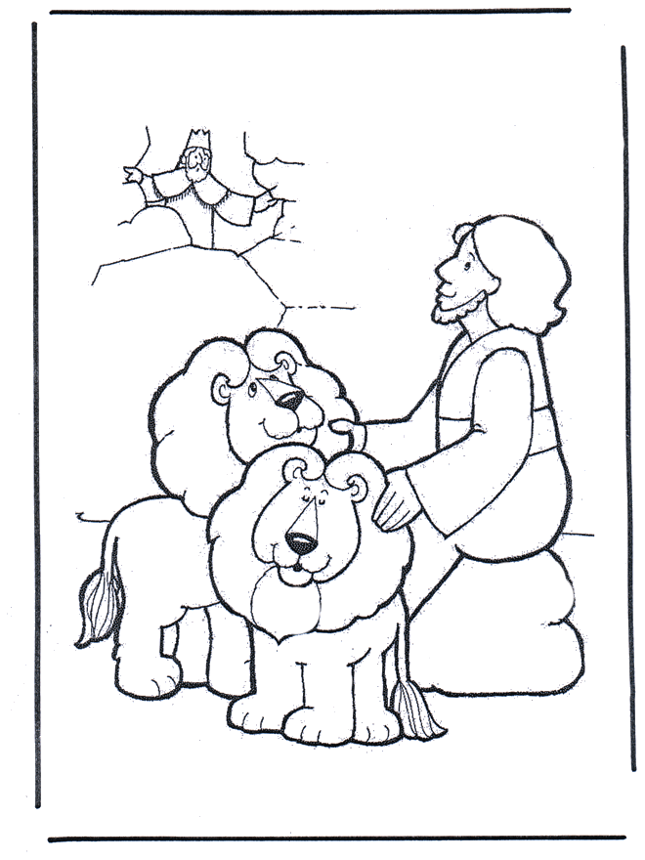

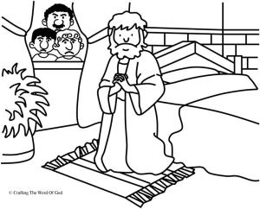
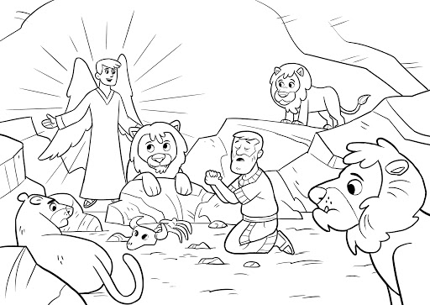

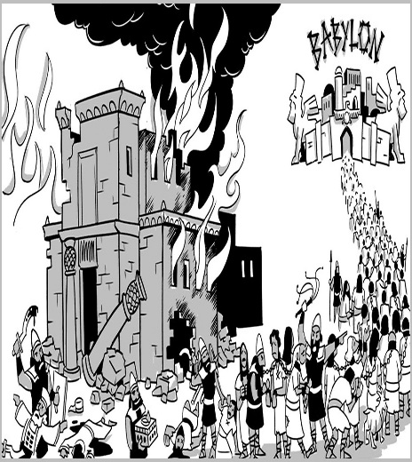

DAVID

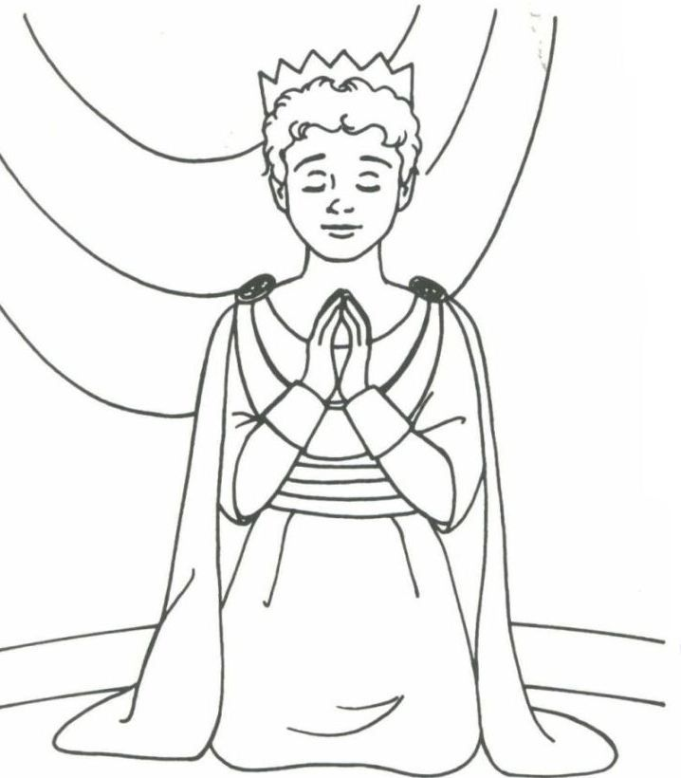

The Lord is my shepherd; I shall not want. He makes me to lie down in green pastures; He leads me beside the still waters. Psalm 23:1

JONAH
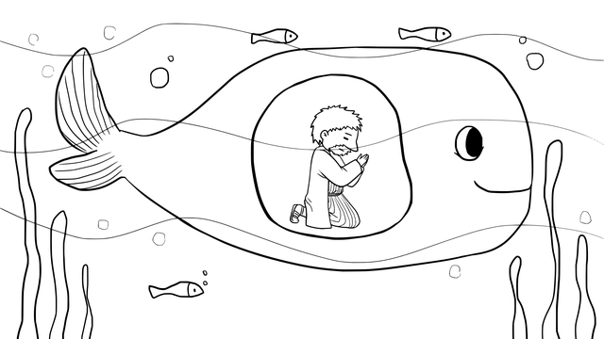
Then Jonah prayed to the Lord his God from the fish’s belly. ² And he said: “I cried out to the Lord because of my affliction, And He answered me. Jonah 2:1
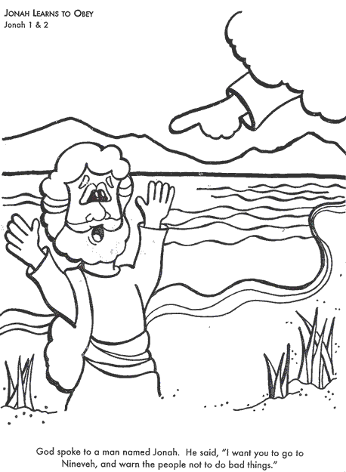
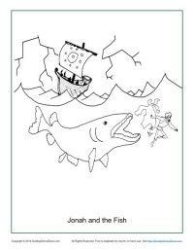

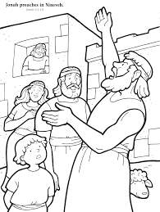

Learn to pray &lap book about people in the bible who prayed

Materials needed;

- coloured card paper – A3 card paper (one)or any hard paper 38cmx25cm (can be a cereal box) – scissors – colouring pencils – glue – paper fastener(optional) – small elastic bands or ribbons

-PDF images (provided) printing of people in the bible who prayed (Samuel-Daniel -Jonah – David)

- pdf (provided) printing for the cover of lap book

- worksheets (provided) printing

