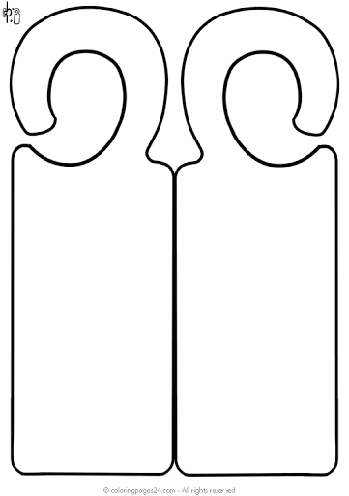
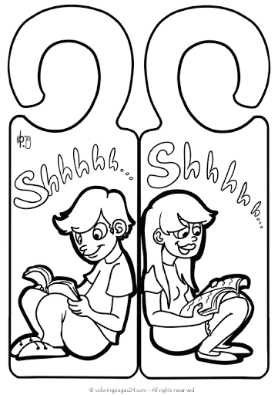
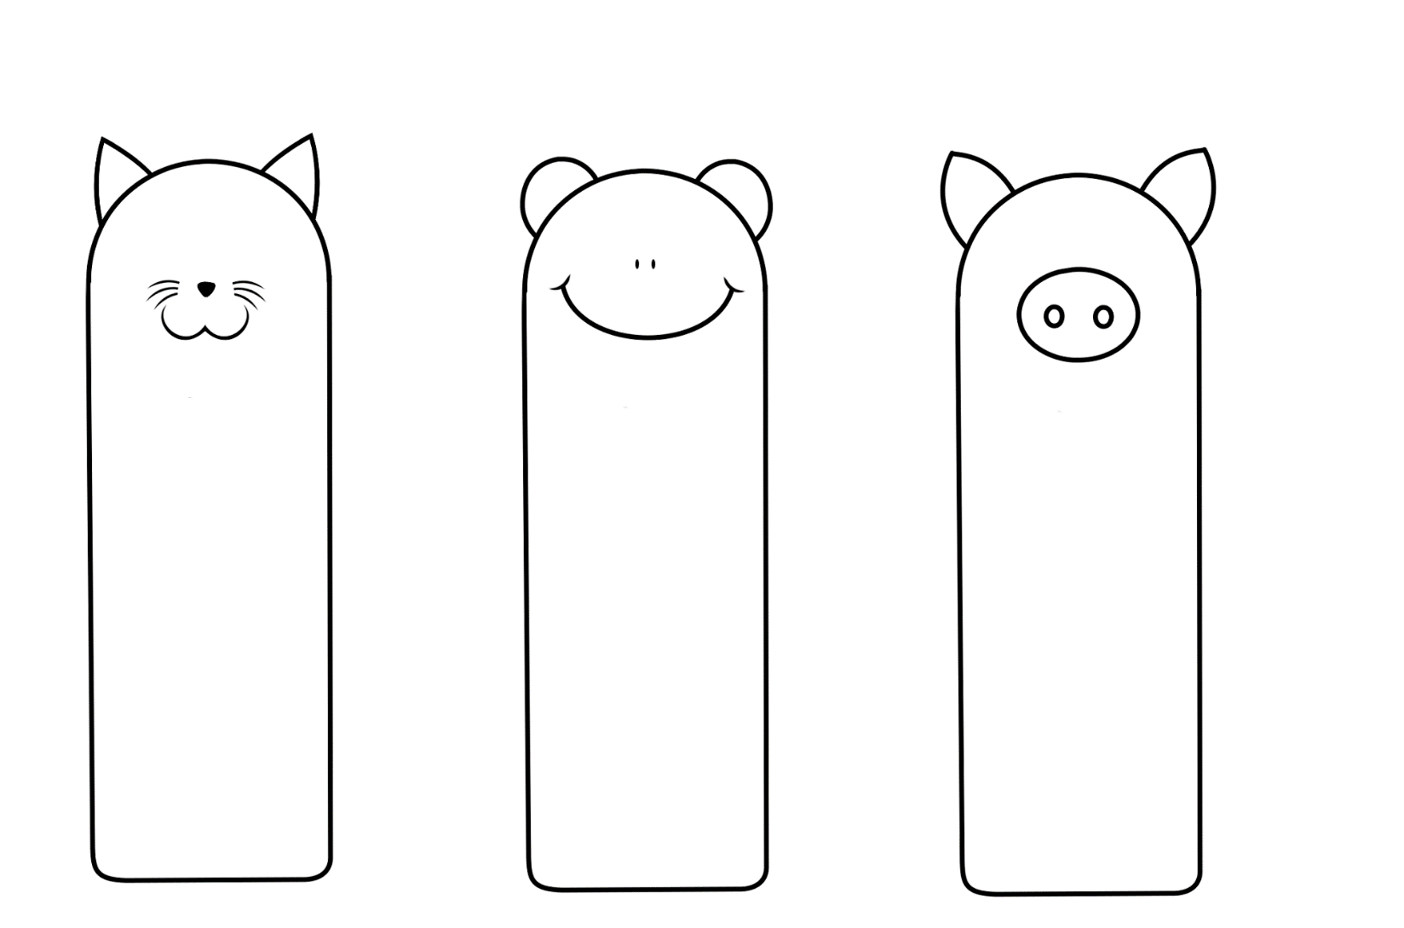
“Today a reader, tomorrow a leader.” – Margaret Fuller

“Reading is to the mind what exercise is to the body.” – Richard Steele

“Reading without reflecting is like eating without digesting.” – Edmund Burke

BY BEHOLDING WE  BECOME CHANGE  (2 Corinthians 3:18) | LET US NOT  BECOME WEARY  IN DOING GOOD  (Galatians 6:9) | A CHEERFUL HEAR  IS GOOD MEDICINE  (Proverbes 17:22)
“GOD RESISTS  THE PROUD, BUT  GIVES GRACE TO  THE HUMBLE.”  (1 Peter 5:5) | BY BEHOLDING WE  BECOME CHANGE  (2 Corinthians 3:18) | LET US NOT  BECOME WEARY  IN DOING GOOD  (Galatians 6:9)
GOD RESISTS  THE PROUD, BUT  GIVES GRACE TO  THE HUMBLE.”  (1 Peter 5:5) | A CHEERFUL HEAR  IS GOOD MEDICINE  (Proverbes 17:22)

