AREA 8 CURRICULUM CAMP

26th May – 29th May, 2017

This document is a guide, which, if followed, will have you and your club ready for our Area Curriculum Camporee. This document includes the application forms, medical forms, church board approval forms and camp equipment check lists.
Area 8 Adventurer Coordinator: Tyronne Waldron

Table of Contents
The Campsite 3
Address 3
Getting to the Campsite 3
Road Map 3
Site Map 4
Camp Registration 5
Admin Folder Inspection 5
Child Protection 5
Medical Care 5
Dress Code 6
Scarf 6
Dress Uniform 6
Field Uniform 6
Camp Itinerary & Programming 7
Camp Staff 8
Other Information 8
Friends 8
Companions 8
Explorers 8
Rangers 8
Voyagers 8
Guides 8
Ordnance Survey Maps 8
Stationary Items / Chairs / Rucksacks 8
Activities 9
Camp Gear – Individual 9
Camp Gear – Club 10
Church Board Acknowledgement 11
Emergency Contact Information 12
Admin Folder Inspection Form 13
Campsite Inspection Form 14
Application Forms 15
Club Application Form 16
Adventurer/Staff Application Form 17
Medical Form 18
Campsite Layout 19

The Campsite

Address

http://www.eatonvale.co.uk
The address of Eaton Vale is:
Eaton Vale Scout and Guide Activity Centre,
Church Lane
Eaton
Norwich
Norfolk
NR4 6NN

Getting to the Campsite

Road Map
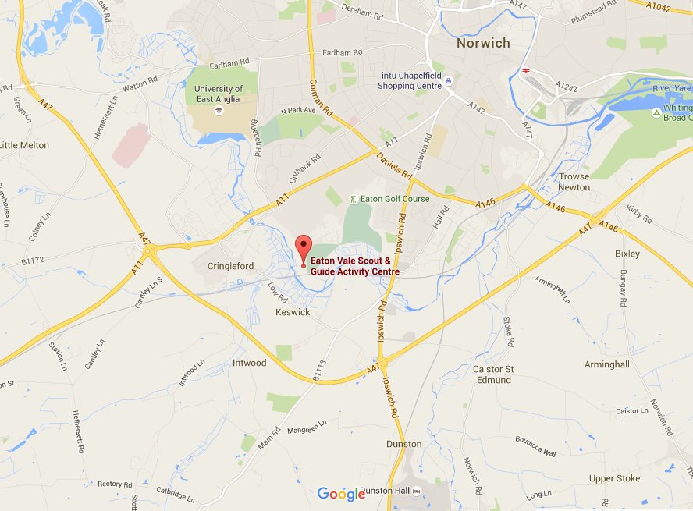

Site Map
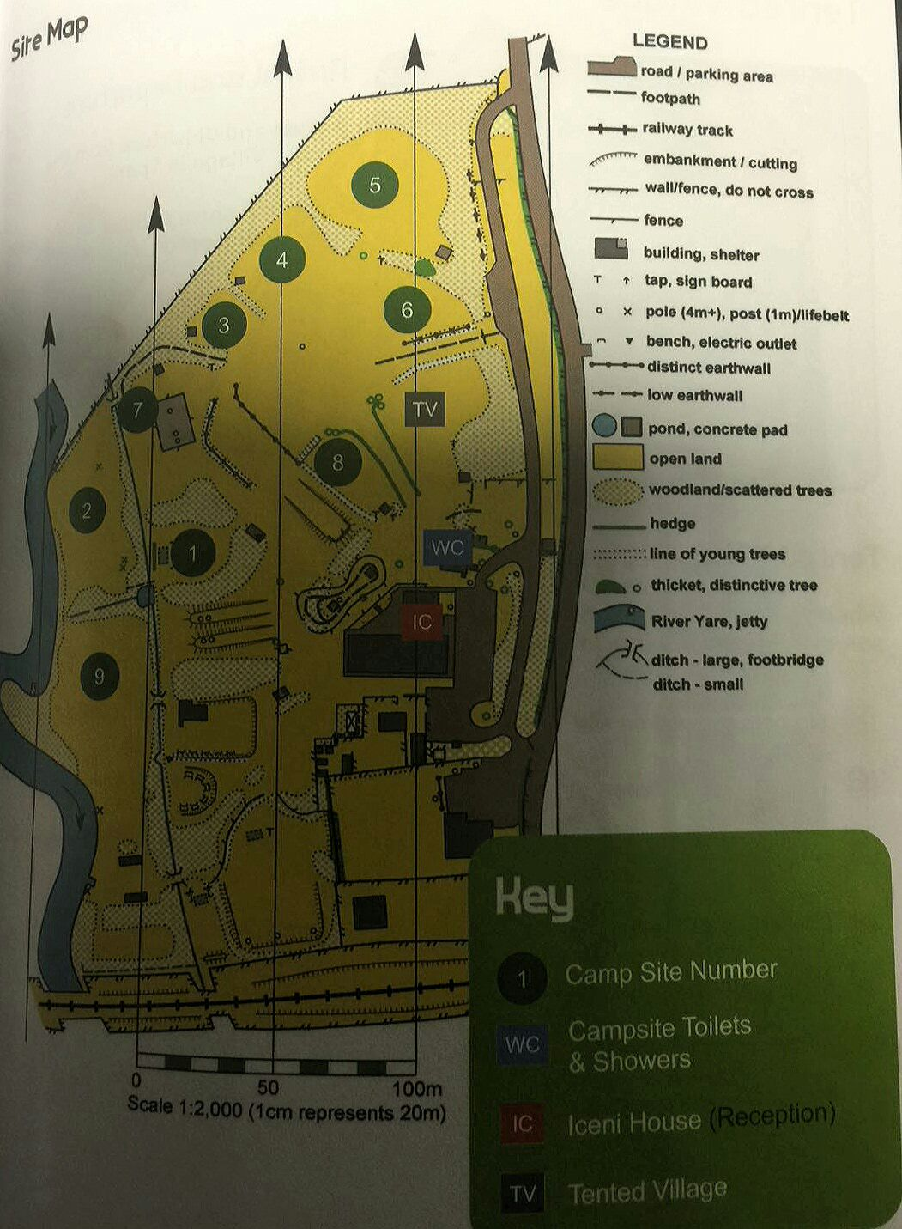
We will be in the tented village and on Site 8..

Camp Registration
On arrival, club directors are to register every member of their group at the Registration Desk located in Iceni House.

Admin Folder Inspection
As part of the registration process, folders will be collected on arrival and returned to clubs after they have been inspected. Clubs are asked to ensure that their folder is organised in the same sections and order as the Administration Folder Inspection form.

Child Protection
The local Church Board is responsible for ensuring that leaders, counselors and instructors attending the camp meet the requirements of the British Union Child Protection Policy: Keeping Our Church Family Safe.

Medical Care
Each club is responsible for providing medical care for their own group.
At least one member of the Club First Aid Team should be qualified to a minimum level of First Aid at Work. The team must also ensure that they have an appropriate first aid kit for the size of the group and the nature of the activities.
A completed Medical Information form for each member of the group must be obtained and kept as part of the club Administration Folder.
Clubs may carry, at their own discretion, various over the counter (OTC) drugs, which can then be administered on the advice of those providing first aid.
Over the counter drugs should be stored separately from the first aid kit and may include:
- Sun creams or sprays, at least factor 15
- Lotions for after sunburn treatment
- Insect bite cream
- Pain Killers - Paracetamol, Co-codamol 8/500
- Anti-inflammatory drugs - Ibuprofen (also known as neurofen)
- Anti-diarrhoeal - Loperamide
- Constipation - Plenty of Fruit and Vegetables, if this fails, lactulose
- Antihistamines (for insect bites)

A completed Medical Information form for each member of the group must be obtained and kept as part of the club Administration Folder
- Chlorpheniramine (Piriton) Sedating
- Cetirizine Non-sedating
- Anthisan cream

Any other drugs, such as antibiotics, will have to be provided via the local GP or Accident and Emergency facility.
Group members who need medication (e.g. for diabetes, asthma or hay fever) should bring a double supply of their medication and a spare prescription to take to the chemist. Please ensure that a care plan is attached to the medical form for children with specific health needs ( i.e. asthma inhalers, epipen etc.)
The Club First Aid Team should keep each group member’s medication in a separate bag clearly marked with the individuals name and monitor the distribution carefully. These should be stored in a safe and secure place.

Dress Code
Please pay close attention to the information to follow in this section as our dress code should be adhered to very strictly. In general, modesty is to be expected of all our campers: male, female, Adventurer and staff.

Scarf
The Adventurer Scarf or Master Guide Scarf MUST be worn at ALL times throughout this camp. The scarf is a part of field uniform and the dress uniform. There will be no excuse for not wearing your scarf while at camp.

Your scarf MUST be worn at ALL times throughout this camp.

Dress Uniform
The dress uniform is NOT needed for this camp.

Field Uniform
A field uniform (Church, Area or SEC field uniform) should be worn at all times throughout the camp. REMEMBER, the scarf is part of the field uniform.
The SEC Field Uniform is

Camp Itinerary & Programming

SEC Area 8 Adventurer Curriculum Camp
26th May – 29th May, 2017
Eaton Vale Scout and Guide Activity
Church Lane, Eaton, Norwich, Norfolk, NR4 6NN
TIME TABLE

LIGHTS OUT AT 2300hrs!

Camp Staff
The camp co-ordinators are Tyronne Waldron and Kim Roberts-Waldron
There will be no other staff apart from your club staff. It means that each club MUST ensure that they have adequate staff to cover the number of Adventurers they bring.

Other Information
Each club will need to bring the following items which your Adventurers will use to fulfil the various honours and course requirements. Please note that these items are per participant NOT per club.

Friends
Ropes for knots
Board for Knots
Glue for knots Board
Small back pack for the hike
Water purification tablets

Companions
Ropes for knots
Board for Knots
Glue for knots Board
Small back pack for nature walk

Explorers
Topographical map (any)

Rangers
Cardbord box
Kitchen foil (loads)
Back pack – 1 per club would do
Ingredients to mix and bake a cake

Voyagers
Own stove, tent, sleeping gear.
Rucksack for overnight hike
Utensils to cook their own food

Guides
Ropes for Lashing

Ordnance Survey Maps
Map details:
Ordnance Survey ‐Maps: (OPTIONAL)
OS 237 NorwichOL 40 – The Broads

Stationary Items / Chairs / Rucksacks
As this is a Curriculum Camporee, all Adventurers MUST have a notebook (writing paper to place into their folder), pens, pencils, colouring pencils, rubber, sharpener and a clip board where possible.
Everyone will be required to bring a camping chair as there will be no chairs available for us to use
It is recommended that ALL Adventurers use Rucksacks rather than suitcases or any other luggage

Activities

Camp Gear – Individual
Bible
Adventurer Folder
Club Field Uniform (including Scarf)
Sleeping bag
Sleeping mat
Underwear
Spare top layers as necessary
Fleece
Waterproof coat & trousers
Toiletries
Torch
Woolly hat
Cap
Personal Medication (if required)
Dining sets (plate, cup, and spoons)
Compass
Camp Chair/stool

Camp Gear – Club
Kitchen Tent (NOT Required)
Kitchen preparation tables (NOT Required)
Stove burner (NOT Required)
Gas & regulator (NOT Required)
Kitchen Lamp (NOT Required)
Pot, pans & serving implements (NOT Required)
Food storage boxes
Food containers
Water containers
Drink containers
Cleaning supplies: mop & bucket, dust-pan & brush, broom etc (NOT Required)
Washing-up bowls & liquid (NOT Required)
Fire blanket, fire buckets
Cool box
Dining Tent ( If you have a big one and transport please bring )
Tables & benches (could be useful….)
Sleeping tents (See list under tent layout)
Sleeping Mats
Extra groundsheets
Tool box (lockable - use an export barrel)
Flat head & cross head screwdriver
Wooden mallet
Hammer
Extra gas hose & jubilee clips (NOT Required)
Sisal & polypropylene rope
Knife
Bow saw
Boundary tape (red & white)
Wet-pit stakes & bin liners
Garden gloves & safety glasses
Safety Goggles
Measuring tape/rope
Disposable gloves

Church Board Acknowledgement
SEC Area 8 Adventurer Curriculum Camp
Eaton Vale Scout and Guide Activity Centre  Church Lane, Eaton, Norwich, Norfolk, NR4 6NN  26th May – 29th May, 2017 |  | Area 8
Adventurer Clubs
Group Leader Details

Title: Mr/Mrs/Ms/Miss/Other …………………………………………………………..………………
Surname ………………………………… First Name ...………………………….………………
Address .....................................................................................................................................
……………………………………..……... Post Code ….…………………………………………..
House Telephone……………..….….…. Mobile .……………………………………….…………
Email Address ………………………………………………………………………………………….

Group Details

Total Number of Adventurers ………………………….

Total Number of Club Staff ………………………….

Church Board Approval

We, the members of the

………………………………………………………………………………………………………..

Church Board, confirm that the group leader is a suitably responsible person to lead our Adventurer club to the Adventurer Curriculum Camporee and that we are satisfied with the Risk Assessment they have presented to us.

We confirm that all members of staff meet the requirements of the British Union Child Protection Policy: Keeping our Church Family Safe and that each person has Club Insurance cover.

We understand that the cost of this Adventurer Curriculum Camporee is £45 per person. £30 per adult NOT taking part in the paid activities. £30 per child under 10ys NOT taking part in the paid activities. (Children not of Adventurer age are unable to participate in the activities due to insurance restrictions. Please Note: This is not an Adventurer Camporee) All payments are to be made in full by 30th June 2015

Signed …………………………………………………………… Date ………………………………
(Church Clerk on behalf of Church Board)

Emergency Contact Information
SEC Area 8 Adventurer Curriculum Camp
Eaton Vale Scout and Guide Activity Centre  Church Lane, Eaton, Norwich, Norfolk, NR4 6NN  26th May – 29th May, 2017 |  | Area 8
Adventurer Clubs

Name of Club ________________________________________________________

Child’s Name | Emergency Contact Name | Emergency Contact Number

Admin Folder Inspection Form
SEC Area 8 Adventurer Curriculum Camp
26th May – 29th May, 2017  Church Lane, Eaton, Norwich, Norfolk, NR4 6NN  Eaton Vale Scout and Guide Activity Centre |  | Area 8
Adventurer Clubs

Name of Club ________________________________________________________

One Point Per Item
Section One – Club Information |  | Section Three – First Aid
Copy of Church Board Registration Form |  | One First Aid at Work Certificate
Individual Application Forms |  | Section Four – Risk Assessment
Individual Medical Forms |  | Travel Plan from start to Campsite
2 copies of Named List with Emergency Contact Details |  | Tent Allocations
 |  | Counsellor allocations
Section Two – Cooks Information |  | Club Code of Conduct
Head Cook Health & Hygiene Certificate/ or In-house Food Awareness Certificate |  | Emergency Plan to take someone to hospital
Individual Meal Plan |  | Emergency Plan to take someone home
Cooking & Washing Up Rota |  | Travel Plan from Campsite to finish point
 | Total Points
Club Director's Signature:
Inspector's name:
Please print:

Campsite Inspection Form
SEC Area 8 Adventurer Curriculum Camp
Church Lane, Eaton, Norwich, Norfolk, NR4 6NN  Eaton Vale Scout and Guide Activity Centre  26th May – 29th May, 2017 |  | Area 8
Adventurer Clubs
Name of Club ________________________________________________________
One Point Per Item
Campsite Layout |  |  | Cook Tent
All tents 3m away from adjoining pitch boundary |  |  | Gas Bottles safe & secure
All sleeping tents 3m apart |  |  | All food stored in sealed containers
Cook tents and altar fires 6m apart |  |  | All prep areas clean
No rubbish on pitch |  |  | Fire blanket or bucket of water/sand
Dining Shelter |  |  | Cleaning fluids safely stored
Clean & Tidy |  |  | Wet-pit area clean & tidy
Sleeping Tents |  |  | Kitchen Staff Inspection
Guy ropes taut and in line with flysheet seams |  |  | Cooks hat or hairnet
Guy ropes in line with tent poles |  |  | Cooks Apron
Nothing touching the tent inner walls
Inside clean & tidy |  |  | First Aid
Structures & Equipment |  |  | First Aid kit appropriate for the size of the group
All structures safe & secure |  |  | Individual medical bags as required
All tools & equipment safely stored |  |  | Individual medication/Dispensing Checklist
 |  | Total Points
Club Director Signature:
Inspectors name:
Please print:

Application Forms

Activities Application Form
SEC Area 8 Adventurer Curriculum Camp
Eaton Vale Scout and Guide Activity Centre  Church Lane, Eaton, Norwich, Norfolk, NR4 6NN  26th May – 29th May, 2017 |  | Area 8
Adventurer Clubs

Club Name: ____________________________________________

Contact Number: ____________________________________________

Your kids can pay to do one(1), two(2) or three(3) site activities. These activities MAY include Canoeing, Raft Building, Trapeze, Jacobs Ladder, and Archery.

We do not yet know which activities will be available to us!

One Activity: £6.80
Two Activities: £13.00
Three Activities: £18.40

No. Of Kids doing 1 Activity
No. Of Kids doing 2 Activity
No. Of Kids doing 3 Activity
Total Activities Being Done
Total Money Paid
Payment Reference

Club Application Form
SEC Area 8 Adventurer Curriculum Camp
Eaton Vale Scout and Guide Activity Centre  Church Lane, Eaton, Norwich, Norfolk, NR4 6NN  26th May – 29th May, 2017 |  | Area 8
Adventurer Clubs
Cost: £37 per Adventurer (Accommodation, Resources & Food).
Cost: £40 per Adult (Accommodation, Resources & Food).

Club name: ____________________________________________

Club Leader: ____________________________________________

Contact Number: ____________________________________________

Email: _________________________________________________

Class | No. Of Males | No. Of Females
Friends

Companion

Explorer

Ranger

Voyager

Guides

Adults

Adventurer/Staff Application Form
SEC Area 8 Adventurer Curriculum Camp
Eaton Vale Scout and Guide Activity Centre  Church Lane, Eaton, Norwich, Norfolk, NR4 6NN  26th May – 29th May, 2017 |  | Area 8
Adventurer Clubs
Cost: £37 per Adventurer (Accommodation, Resources & Food).
Cost: £40 per Adult (Accommodation, Resources & Food).

Club Name_____________________ Adventurer Class_____________________
Attach Photo here
Camper’s Details
Campers Name ___________________________________________ Birth Date ___/___/_____
Age ___ Parent’s/Guardian’s Name(s) ______________________________________________
Address _______________________________________________________________________
City ______________________County______________________ Postcode________________
Home Phone _______________________ Emergency Phone ___________________________

Photography Consent
Current regulations relating to The Data Protection Act 1998 requires that we obtain your consent for images taken of your son/daughter (under 18 years) which are used in either video or still shots. Only first names might be used and/or the name of the club to which they are a member. For further information on our Photographic Policy, please contact the SEC Office. As images will be recorded at all events you may wish to consider this in your application if consent is not given.

Please read the photography consent section above and tick yes if you give consent. YES, NO

Child Protection - Staff
Criminal Records Bureau Certificate Number: __________________________________________
Child protection training: have you done the KCFS training? YES, NO
Every person over the age of 16years must have a DBS certificate,

I hereby give permission for my child to attend this event and to take part in the activities arranged. I agree to notify the leaders should there be any change to the information given.

Signed: ______________________________________ Date: ___/___/_____

Area 8 Adventurer Coordinator  Tyronne Waldron  +44 795 606 7485  tyronne.waldron@gmail.com | Administrative Assistant  Kim Roberts-Waldron  +44 7904 197510  ktahira1@yahoo.co.uk

Medical Form
Church Lane, Eaton, Norwich, Norfolk, NR4 6NN  Curriculum Camp 26th May – 29th May, 2017  Medical Form |  | Area 8
Adventurer Clubs
CLUB NAME__________________________ AREA ____ Emergency Phone _______________________
Campers Name ___________________________________________ Birth Date ___/___/_____ Age ____
Parent’s/Guardian’s Name(s) ______________________________________________________________
Address ________________________________________________ City ____________________________
County____________________ Postcode ____________ Home Phone ____________________________

Medical Details:
☑=YES ☒=NO
Have you had: |  | Do you wear: | Please give the date of the last tetanus injection __/__/__.  If you are currently taking medicine please give the name of the drug and dosage details  _________________________  Do you have any food allergies?________________
Rheumatic fever:  |  | Glasses: 
Asthma:  |  | Contact lenses:
Fainting spells:  |  | Dentures: 
Diabetes: 
Kidney Disease:  |  | Are you allergic to:
Heart trouble:  |  | Penicillin: 
Menstrual problems: |  | Anaesthetic: 
Hernias: 
Travel sickness:  |  | Tetanus injection in last 5 years? 

Name of GP/Doctor _____________________________________Surgery____________________________________
Address ___________________________________________ City ____________________County________________
Postcode ____________ GP/Doctor Phone _________________________ NHS Number ______________________

Other Information
If there is anything else that should be considered by the club, relating to the health and/or ability of the above mentioned person, please state clearly below: __________________________________________________________________________________________________________________________________________________________________________________________________

Authorisation
This health report is correct as far as I know, and the person described has permission to engage in all prescribed activities, except as noted by me. In the event of an emergency, I hereby give permission to the physician selected by the adult leader in charge to hospitalise or treat including proper anaesthesia, injection, or surgery for the person this form applies to.

_________________________________________
Signature of Parent/Guardian

Campsite Layout

